Importing and exporting images from PACS using Velocity

Exporting DICOM files from PACS
- Open the Velocity Application on Citrix
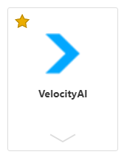
- Login using your Velocity user ID and password (Most likely your old Eclipse login)
- From the top middle, select the “5-Dots” icon
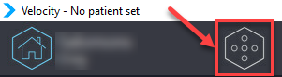
- From the secondary icons that appear below select “Query”
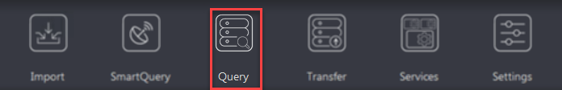
- In the “Query Location” drop-down menu at the top, select “PACS Query”
 | 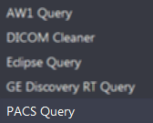
- Enter appropriate query details and click query
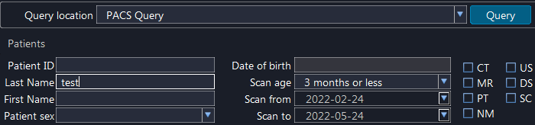
- Identify the appropriate study from the list that appears. Note: There is a known bug that all study descriptions for a given patient show as identical.
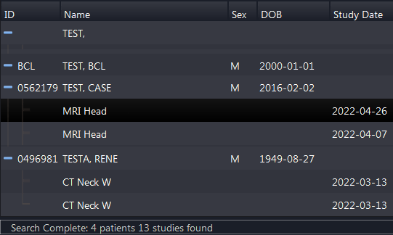
- From the selected study, select the desired image series on the right and click send
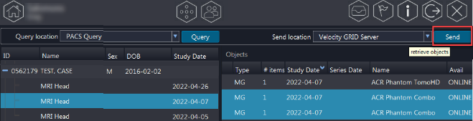
- Wait for the image import to complete. The import progress can be monitored in the “Services” section:
  - From the top middle, select the “5-Dots” icon

  - From the secondary icons that appear below select “Services”
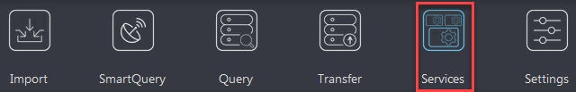
  - Under the “Import” tab The import progress will display
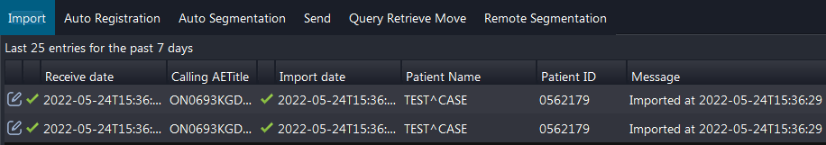

- Once the import is complete, select the “Home icon from the upper left

- The imported patient should appear at the top of the list. The Icons and numbers will indicate the number any type of images imported.
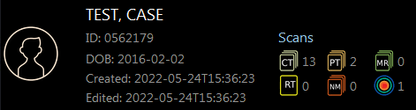
- Right click on the patient and select “Export”
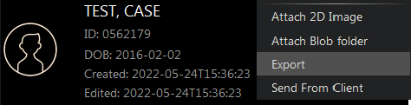
  - You will be prompted to select a folder. use a folder such as: “m:\DICOM_IMPORT\From Velocity”
  - At the bottom of the window Ensure that “Original Encoding” is selected and Use Velocity Patient Information is Deselected
  - Select the image sets you wish to export and deselect the attached structure sets.
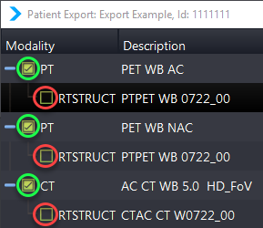
  - Export progress will be shown at the bottom:

